Prob. Sci., xx (xx) yyyy
 | PROBECELL SCIENCE  Journal homepage: https://probsci.com

Title for paper submitted to Probecell Science
Author Nameª*, Author Name^{b}
ª* Department, Institute Name and Address.
^{b} Department, Institute Name and Address.

*Corresponding Author: Department, Institute Name and Address.
E-mail Address: email id (Author Name), email id (Author Name).

ARTICLE INFO |  | ABSTRACT
Original Research Article  Received: XXXXXXXX  Accepted: XXXXXXXX  KEYWORDS  First keyword,  Second keyword  Third keyword,  Fourth keyword,  Fifth keyword.  (Mention 4-5 keywords) | The abstract should be not more than 250 words, and organized in this structure: An opening sentence that sets the question that you address and is comprehensible to the general reader, background content specific to this study, results, and a concluding sentence. It should be one paragraph only.

Graphical Abstract:

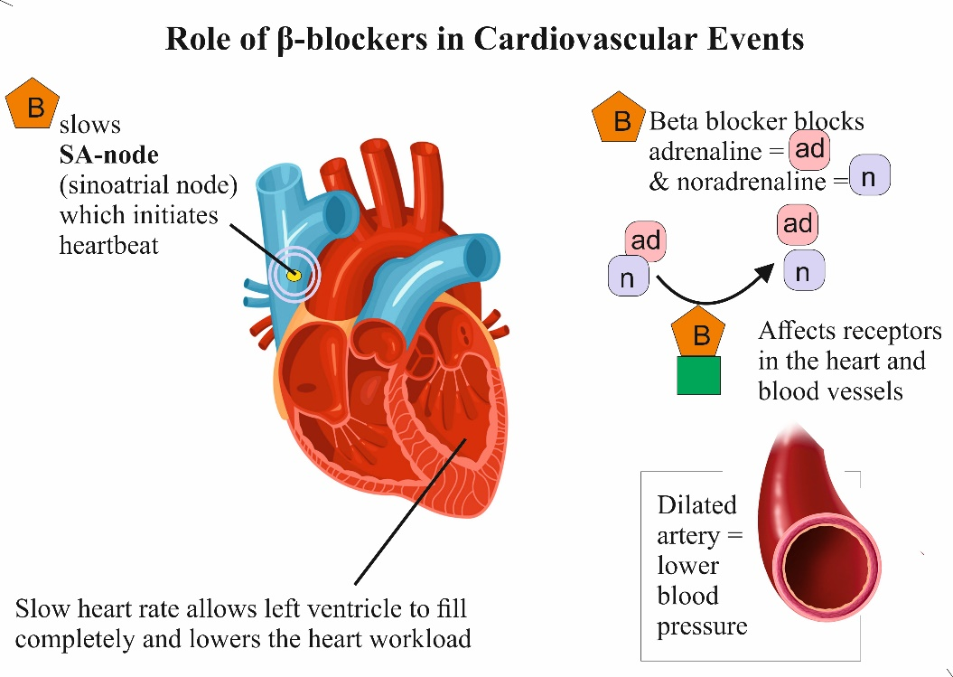

Introduction
In Introduction you can mention the introduction about your research.

Literature Review
Comprehensive literature should be reported relevant to the presented study.

Materials and Methods
Can include the Materials and Methods here. Additional references should be cited here and included in the main reference list.
If equations were used it should be converted by using MS Office equation editor and pasted as image at proper place. All equations should be grouped or may be prepared using equation editor software. Following are the example of equation you use in your article.
$$I\left(X.X\right)=\sum{P x.y\left(X.Y\right)\log_{2}{\frac{p.XY(x.y)}{PX.\left(x\right).P.Y(y)}}}$$ | (1)

$$I\left(X.X\right)=\sum{P x.y\left(X.Y\right)\log_{2}{\frac{p.XY(x.y)}{PX.\left(x\right).P.Y(y)}}}$$ | (2)

Table 1. Sample Table that fit on single column
Sl.No. | Particulars 1 | Particulars 2 | Particulars 3
1. | contents | contents | contents
2. | contents | contents | contents
3. | contents | contents | contents
4. | contents | contents | contents
5. | contents | contents | contents

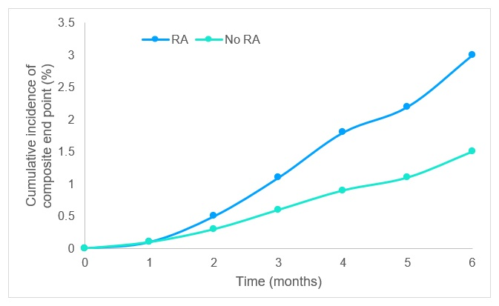
Figure 1 Flow chart for rheumatoid arthritis

Table 2. Sample Table that fit on both column
Sl.No. | Particulars 1 | Particulars 2 | Particulars 3 | Particulars 4
1. | contents | contents | contents | contents
2. | contents | contents | contents | contents
3. | contents | contents | contents | contents
4. | contents | contents | contents | contents
5. | contents | contents | contents | contents

Result and Discussion
Present the detailed result and justification for the obtained results. Author can also take the help of graphs, images and table to present the result and make it easily interpretable.
The bulleted points should be presented like this:
- Point one.
- Point two.
- Point three
- Point four
- Point five.

Conclusion
A conclusion section is not required. Although a conclusion may review the main points of the paper, do not replicate the abstract as the conclusion. A conclusion might elaborate on the importance of the work or suggest applications and extensions.
Conflict of Interest
Author(s) shall declare the conflict of interest Yes/ No before submission of manuscript for publication. The conflict of interest as mentioned in manuscript before references section or by the use of any free plagiarism checker, the author(s) shall provide the plagiarism report with submission of manuscript.
Ethical Compliance Standard
When reporting experiments on human subjects, authors should indicate whether the procedure follows were in accordance with the ethical standards of the responsible committee on human experimentation. Do not use patients' names, initials, or hospital numbers, especially in illustrative material. Papers including animal experiments or clinical trials must be conducted with approval by the local animal care or human subject committees, respectively.
Acknowledgement
In general, the most important person to thank in the acknowledgment is your research advisor or major professor overseeing your project/research and other supervising academics directly involved with your research work. Use the singular heading even if you have many acknowledgments.
References
References should be in alphabetical order. Author must follow the Elsevier-Vancouver (https://open.mendeley.com/use-citation-style/elsevier-vancouver) citation style in the manuscript. You can also use the standard referencing tools like Mendeley (https://www.mendeley.com/download-desktop-new/) to format your citations. Following are some sample reference formatting style:
Example:
Conference Article [1]
- Chandra TB, Verma K. Pneumonia Detection on Chest X-Ray Using Machine Learning Paradigm. In: Chaudhuri BB, and Nakagawa M, and Khanna P, and Kumar S, editors. Proc. Third Int. Conf. Comput. Vis. Image Process., Springer Singapore; 2020, p. 21–33. https://doi.org/10.1007/978-981-32-9088-4_3.
Journal Article [2]
- Chandra TB, Verma K, Singh BK, Jain D, Netam SS. Coronavirus disease (COVID-19) detection in Chest X-Ray images using majority voting based classifier ensemble. Expert Syst Appl 2021;165:113909. https://doi.org/10.1016/j.eswa.2020.113909.
Book Chapter [3]
- Taghipour M. Lateral Radiograph. Essent. Radiol. Rev., Springer International Publishing; 2019, p. 41–3. https://doi.org/10.1007/978-3-030-26044-6_10.
Book [4]
- Shalev-Shwartz S, Ben-David S. Understanding machine learning: From theory to algorithms. Cambridge university press; 2014.
Web contents [5,6]
- Global Tuberculosis Report 2019. World Heal Organ 2019. https://www.who.int/tb/publications/global_report/en/ (accessed March 13, 2020).
- Sprawls P. The Physical Principles of Medical Imaging, 2nd Ed. 2018. http://www.sprawls.org/ppmi2/NOISE/ (accessed July 25, 2018).

